A Memorandum

**Date:** October 4, 2018

**To:** Nuri Emanetoglu, Associate Professor / Andrew Sheaff, Lecturer

**From:** Ryan Dufour, Undergraduate (CE) RD / Phillip Robb Undergraduate (EE) PR

**Subject:** Written Progress Report 2

This project is to build a guitar tuner for an acoustic guitar. The device receives an audio signal from a guitar that is sounding only one note, and displays the fundamental frequency of the note being played. The tuner is to be microphone based, as opposed to the clip-on versions that mount on to the instrument. The tuner will calculate and display the fundamental frequency. The following table displays the functional blocks.



**Figure 1: Functional blocks of guitar tuner**

The team plans on demonstrating the functionality of the design during qualifiers. The power supply will be demonstrated by connecting to an external load, the signal conditioning will be demonstrated via network analysis using the Digilent Analog Discovery 2, the accuracy of the frequency detection will be demonstrated by comparing the value displayed by the team’s design with that of a commercially available tuner. By this stage the teams plans to have migrated to a custom PCB.

The mechanical acoustic wave detection has been constructed. the microphone test circuit is shown in Figure 2. This circuit has been used to capture 4 acoustic guitar string signals.

**Figure 2: Microphone test circuit**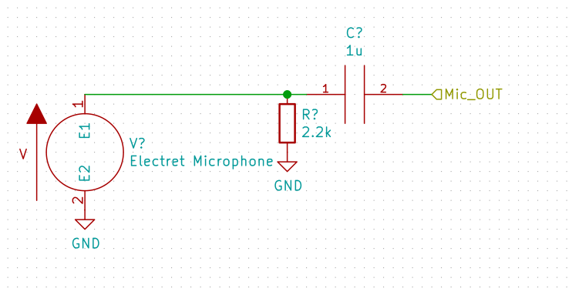

Currently the power supply is in the testing phase. Parts have arrived and the integrated circuit

has been soldered to the testing breakout board. This signal that was recorded with the Analog Discovery 2 was sampled at 10 kHz. The resulting CSV files are being used to debug and increase the robustness of the frequency analysis algorithm in Matlab.

The signal conditioning circuit is currently in a redesign phase, which the design being shifted to a sixth order Sallen-Key topology Butterworth filter. It was discovered upon testing that the previous design was not able to adequately make the transition necessary for the team’s stopband specification. prototyping of this stage will proceed once optimal values have been found. The microphone is represented as a voltage source in the schematic..

The data analysis functional block has made progress in regards to the frequency detection algorithm; autocorrelation with a brute force peak detection method have been prototyped in Matlab using the output of the prototype microphone. The main methods being applied can be seen in Figure 3.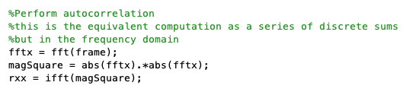

**Figure 3: Main loop code**

The peak detection then goes on to do further conditioning, namely normalization of the signal and the removal of negative correlation values. The current test signals for the EAD--e strings are being detected correctly within the specified tolerances. Work is currently underway to recreate the Matlab algorithm in C for a real-time implementation using the CMSIS functions available to the STM32L476 MCU. Currently, the STM32L476 Discovery board with the sampling code framework from ECE486 is being used prototype this real-time implementation. Final version of this code will not use the ECE486 framework.

Kicad with the “eeschema” helper is being used to generate the captured schematic. Kicad will also be used to generate the PCB design. In addition, Matlab is being used to simulate the transfer function of the signal conditioning as well as the frequency detection algorithm. The ARM code is being compiled using the cross-compiler tools available on Linux systems and the ST-Link utilities by Texane are being used to flash code to the MCU.